22/4/2020
Nastavna jedinica: Ponavljanje (Future Will, Future going to, Present Simple for Future, Present Continuous for Future)

Dobro jutro djeco, danas ćemo ponoviti glagolska vremena za izricanje budućih radnji i to na način da ćemo provjeriti točnost urađenih zadataka koje sam vam na tu temu zadala 27. 3. 2020. Tijekom nastave na daljinu obrađivali smo futur (buduće glagolsko vrijeme) od 17. 3. – 27. 3. 2020. Naučili smo da buduće događaje možemo izricati uporabom slijedećih glagolskih vremena: Future Will, Future Going to, Present Simple, Present Continuous. Svako od ovih glagolskih vremena se upotrebljava za izricanje određenih budućih radnji što smo predstavili slijedećim grafičkim prikazom:
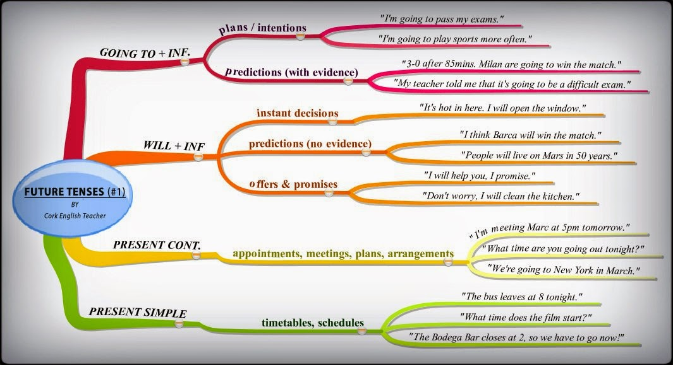

Grafički prikaz je detaljno objašnjen 25. 3. 2020.
Otvorite sadržaje od 25. 3. 2020. i pročitajte barem dva puta sadržaj lekcije.
Ovo su bili zadaci koje sam zadala kao vježbu 27. 3. 2020. Uzmite svoje bilježnice i usporedite rješenja. Ispravite eventualne pogrješke.

- Pogledajte dobro slijedeće rečenice. Imenujte na crtu glagolska vremena koja su u njima upotrijebljena). Razmislite i objasnite zašto se upotrijebilo baš to glagolsko vrijeme za izricanje buduće radnje i kakvu je poruku dobio sugovornik. Uporište za svoje obrazloženje potražite u prethodnoj lekciji.
1 It's cloudy outside. It is going to rain. – FUTURE GOING TO (prediction with evidence)
2 The shop opens tomorrow at 9 o'clock. – PRESENT SIMPLE (schedules)
3 I'm hungry. I'll make a sandwich. FUTURE WILL (instant decision)
4 I'm flying to Madrid this Saturday – PRESENT CONTINUOUS (plans, arrangements)
5 I'm going to fly to Madrid this Saturday. – FUTURE GOING TO (plans, intentions)
6 My train leaves at six tonight. – PRESENT SIMPLE (schedules)
7 We will have a great time. – FUTURE WILL (predictions, no evidence, promises)
8 I hope she won't be strict. – FUTURE WILL NEGATIVE FORM (predictions, no evidence)
9 I'm going to be a vet. – FUTURE GOING TO (plans, intentions)
10 I'm visiting my aunt tomorrow. – PRESENT CONTINUOUS (plans)
Naravno, objašnjenja ste mogli pisati i na hrvatskom jeziku. Bitno je da uočite zbog čega je u rečenici upotrijebljeno upravo to glagolsko vrijeme odnosno kakvu je poruku dobio sugovornik.
Ovo je bio drugi zadatak. Usporedite rješenja i ispravite eventualne pogreške.

- Stavi glagol u zagradi u odgovarajuće glagolsko vrijeme: FUTURE GOING TO, FUTURE WILL, PRESENT SIMPLE ili PRESENT CONTINUOUS
1 The train leaves at 11.45. (leave) – PRESENT SIMPLE (raspored)
2 We are going to have dinner at a nice restaurant on Saturday, but we haven't booked a table yet. (have) – FUTURE GOING TO (planirani događaj u budućnosti)
3 My ski instructor believes it will snow in the mountains tomorrow evening. (snow) – FUTURE WILL (pretpostavka bez dokaza, predviđanje)
4 On Sunday at 8 o'clock I am meeting my friend. (meet) – PRESENT CONTINUOUS (planirani sastanak u bliskoj budućnosti)
5 They are flying to London on Friday evening at 8.15. (fly) - PRESENT CONTINUOUS ((planirani događaj u bliskoj budućnosti)
6 Wait! I will drive you to the station. (drive) – FUTURE WILL (trenutna odluka)
7 The English lesson starts at 8.45. (start) – PRESENT SIMPLE (raspored)
8 I am going to see my sister in April. (see) – FUTURE GOING TO (planirani događaj u budućnosti)
9 Look at the clouds. It is going to rain in a few minutes. (rain) – FUTURE GOING TO (pretpostavka s dokazom)
10 Listen! There's someone at the door. I will open the door for you. (open) – FUTURE WILL (trenutna odluka)

