24/4/2020
Nastavna jedinica: THE WEATHER
Dobro jutro dragi moji učenici. Nadam se da ste raspoloženi za učenje. Kroz nekoliko prethodnih nastavnih jedinica proučavali smo oblike za prošlo vrijeme glagola „biti“ (PAST TENSE “TO BE”). Nadam se da ste svi s razumijevanjem uspjeli naučiti. Ukoliko niste, imate nekih poteškoća ili jednostavno želite dodatno uvježbati ove sadržaje možete pogledati kratke video lekcije na slijedećim linkovima:
https://www.youtube.com/watch?v=yhq1wuu7NFk
https://www.youtube.com/watch?v=kvuWQXR84Xo
Dostavljam vam i rješenja zadataka iz radne bilježnice koje sam zadala uz prethodnu nastavnu jedinicu (22.4.2020.) pa možete usporediti rješenja i ispraviti eventualne pogreške.
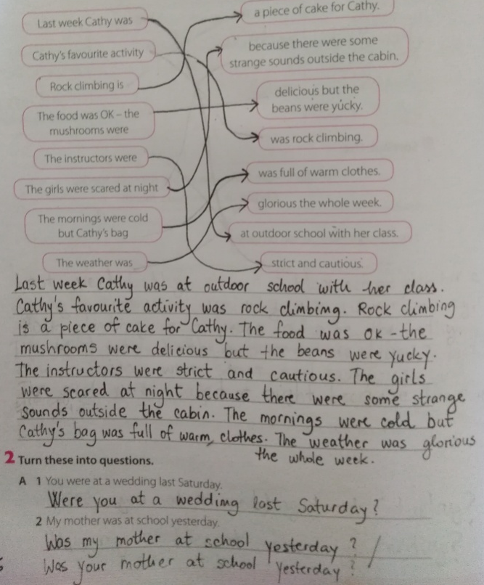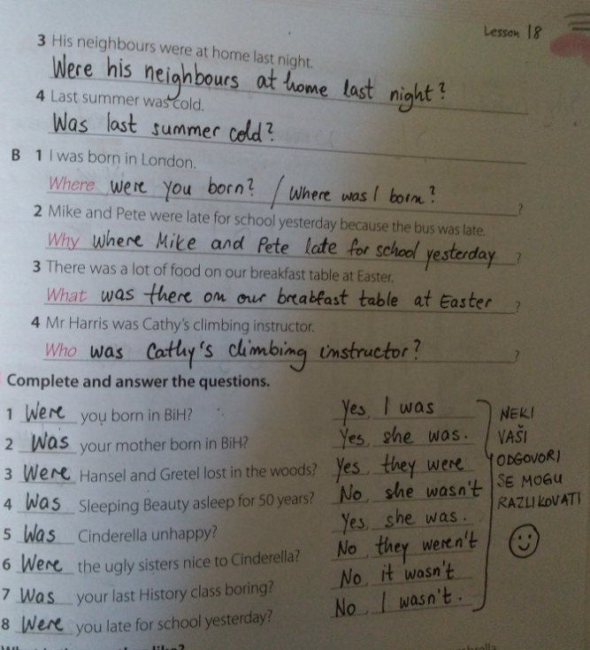
Danas ćemo učiti o vremenskim prilikama/neprilikama. Kako pitamo kakvo je vrijeme danas? What is the weather like today? (What's the weather like?) Kako bismo pitali u prošlom vremenu? Kakvo je vrijeme bilo jučer, prije dva dana, prošle nedjelje? What was the weather like yesterday/ two days ago/ last Sunday? What is the difference between a WEATHER REPORT and a WEATHER FORECAST? Koja je razlika između izraza WEATHER REPORT i WEATHER FORECAST? Ukoliko ove izraze prevedemo na hrvatski jezik lako ćete uočiti razliku. Weather report – izvješće o vremenu (koje nam daje informacije kakvo je vrijeme bilo jučer ili kakvo je vrijeme trenutno); Weather forecast – vremenska prognoza (koja predviđa kakvo nas vrijeme očekuje u narednom razdoblju). Otvorite vaše udžbenike na stranicu 126. Pogledajte riječi na dnu stranice (snow storm, foggy, cloudy, windy, rainy, wet, sunny, warm). Znate li značenje svih riječi? Ove nam riječi govore o vremenskim prilikama/neprilikama. Stavite riječi na odgovarajuće mjesto pored slika na stranicama 126/127 vašeg udžbenika na prazne crte pored riječi weather.
Pročitajte izvješće o vremenu (WEATHER REPORT) za Europu i nakon čitanja dopunite i ostale prazne crte pored slika, odnosno prazne crte pored riječi temperature i town.
This is the weather report for our continent – dear old Europe. Yesterday was no different from the rest of the week. In the north it was cold as usual. In the south it was warm as can be expected for this time of the year. London was foggy with a temperature of 12 degrees centigrade. It was windy and cloudy in Berlin. And the temperature there was 9 degrees centigrade. In Madrid it was rainy again. Unusually wet for this time of the year. And the temperature was 15 degrees centigrade. Let’s see what the weather was like farther south. So, in Rome the weather was really beautiful. It was sunny and warm and the temperature was wonderful 22 degrees centigrade. The north of our continent was the coldest. Actually, it was even colder than usual. In Oslo the temperature was only 0 degrees and there was even a snow storm.
Prepišite u vaše bilježnice slijedeći sadržaj:

THE WEATHER
weather /ˈweðə(r)/ - vrijeme
weather report /ˈweðə(r) rɪˈpɔː(r)t/ - izvješće o vremenu
weather forecast /ˈweðə(r) ˈfɔː(r)kɑːst/ - vremenska prognoza
degrees centigrade /dɪˈɡriːz ˈsentɪˌɡreɪd/ - Celzijevi stupnjevi
(2 °C = 2 degrees centigrade)
EAST /iːst/ - istok
WEST /west/ - zapad
NORTH /nɔː(r)θ/ - sjever
SOUTH /saʊθ/ - jug

snow storm - snježna oluja | foggy - maglovito | cloudy - oblačno
windy - vjetrovito | rainy - kišovito | wet - vlažno
sunny - sunčano | warm - toplo | hot - vruće
cold - hladno

